BTC Turtle Capture Data Sheet
Last revised March 2017

CAPTURE INFORMATION
Site Name: _______________ Recapture? Y or N or Unknown Turtle ID: ___________
Status: Alive or Dead Date (mm/dd/yyyy): ________ Day: _____ Time: ______ AM PM

Capture Method* (1-7): ____ Capture comments: _________________________________________

Observer(s): _________________________________________________________________________

Processed By: ________________________________________________________________________

LOCATION DETAILS
Coordinates (UTM): E___________________, N ______________________ Zone: ________

Datum: WGS 84 Location Description:___________________________________________________ ____________________________________________________________________________________
Air Temp: ____ ˚F or ˚C Sky Index* (0-4): ____ Weather *(1-3): _____ Days since last rain: _____

TURTLE DESCRIPTION

Eye Color: ____ brown ____ pale red ____ bright red ____ other: _______________________________

Sex: M F Unknown SCL min. (mm): ___________

Mass (g):___________________ Max CW (mm):_____________________

Annuli Count: ______ PL Anterior to hinge (mm):____________

Habitat (1-9): ______ PL Hinge to posterior (mm): ___________

Photos taken? Y N Shell height at hinge (mm): ____________
(measured on turtle’s right side)

Capture Method: 1=road capture; 2=while mowing; 3=active search; 4=incidental; 5=radio signal; 6=dog; 7=other
Sky Index: 0= 0% clouds; 1= 25% clouds; 2=50% clouds; 3=75% clouds; 4=100% clouds
Weather: 1= no precipitation; 2=light drizzle/mist; 3=rain
Habitat: 1=field/forest edge (within 6m of boundary); 2=field; 3=pine forest; 4=hardwood forest;
5=stream/river; 6=open wetland; 7=forested wetland; 8=other; 9=mixed pine/hardwood forest
Turtle Data Sheet
Page 2

TURTLE CONDITION & NOTES
Injuries/Defects: None seen ____ Crushed or damaged carapace ____ Crushed or damaged plastron __________
Damaged eye or eyes ____ Missing digits, and/or limbs ____ Skin/soft tissue scars or injuries ________________
Tooth marks on shell ____ Other ________________________________________________________________
Injuries/Defects Notes: ________________________________________________________________________

Illness/Health Issues: None detected. ____ Discharge from ____eyes, _____ mouth, ______ nose. What color is discharge? __________________________________________________________________________________
Discharge from vent. _______ If there is a discharge from vent, what color? ______________________________
Swollen ear ____ left ____right. Swollen eye ____ left ____ right.

Other _______________________________________________________________________________________
____________________________________________________________________________________________

Illness/Health Issues Notes:______________________________________________________________________

Parasites: None detected ____ Leech(es) ____ Tick(s) ____ Other ______________________________________
Parasites Notes: _______________________________________________________________________________

Indicate ID file markings in Figure 1. Show any Injuries, Unusual Scute Patterns, or Defects in Figures 2 and 3: 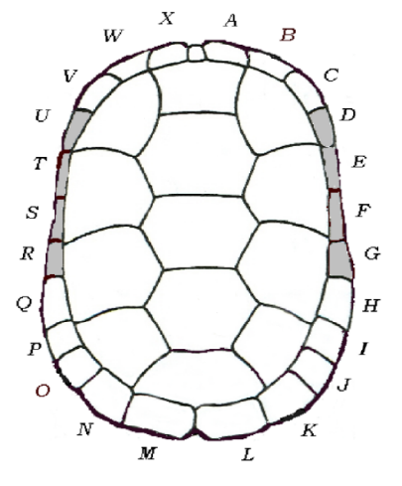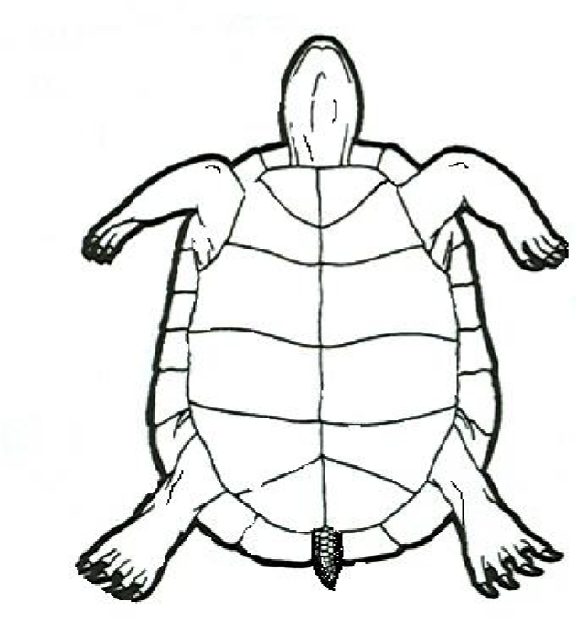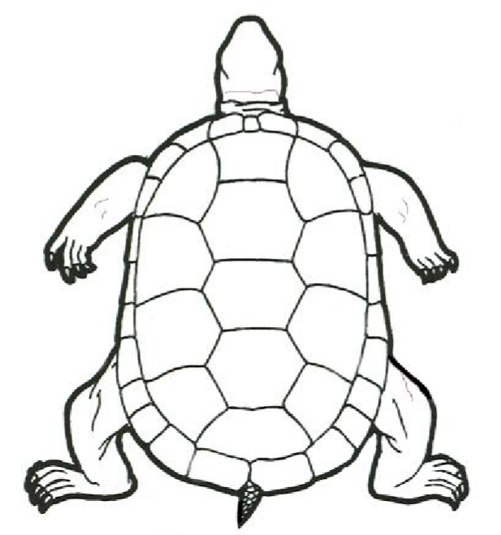

Figure 1 Figure 2 Figure 3
Comments:
Initial when each of the following actions is performed. ________ Entered ________ Proofed _______ Scanned

Appendix B: Sample Turtle Data Sheet Instructions

Instructions for Completing the Turtle Capture Data Sheet

Capture Information

Site name – If a name does not already exist for the property where the turtle was found, invent one. Examples: The Matthews Home Place, Somers Berry Farm, or Camp Chestnut.

Recaptured? – Circle “Y” for yes or “N” for no. Don’t be too hasty. Carefully inspect the turtle for previous marks. Filed notches often fill in with dirt, so run the tip of your fingernail along the edge of the marginals to feel for previously filed marks.
Turtle ID – For newly captured turtles, refer to Marking System for Box Turtles in Chapter 6 or, if previously marked, enter the code.

Status – Record if the turtle is alive or dead. (Note: collecting data on dead turtles is important too.)

Date – Enter the date you are collecting data (mm/dd/yyyy).

Day of week – Enter the day of the week you are collecting data for this turtle.
Time – Record the time this turtle was discovered and indicate whether it was found in the A.M. or P.M.

Capture method – Enter the number that represents the way this turtle was observed: 1= road capture; 2= observed while mowing; 3= active search (you found the turtle by actively looking); 4= incidental; 5= radio signal (turtle found by radiotracking); 6= dog (a dog located the turtle); 7= other (give a complete explanation of any method that does not fit into the previous categories).

Observer(s) – List the complete name of the leader and the name of the group. You need not include all people present.

Processer – The processor does the measuring and fills out the data sheet themselves or is responsible for supervising the recorder. This should be a trained person adhering to the protocol for measurements.
Location Details

Coordinates (UTM): Geographic coordinates should be recorded in the Universal Transverse Mercator (UTM) grid system using datum WGS 84. Easting (E) and Northing (N) are the coordinates to be recorded. If you do not have a personal GPS, you may use UTM finder available free on smartphones from Tremble Navigation (does not need internet connection). World Geodetic System of 1984 (WGS84) is the default datum for the UTM finder on Tremble Navigation.
Location Description – Use semi-permanent landscape features to record location (nothing is permanent, but if you think something is long-lasting, use that feature). This is not a habitat description. Example: turtle found in group campground, approx. 200 meters northwest of bath house, crossing paved road.

Air Temp. – Record air temperature in the shade near where the turtle was found. Use either Fahrenheit or Celsius, but do not forget to circle which one.

Sky Index – Use the following numerical codes for sky conditions: 0= 0% clouds; 1= 25% clouds; 2=50% clouds; 3=75% clouds; 4=100% clouds

Weather – Use the following numerical codes for weather conditions: 1= no precipitation; 2= light drizzle/mist; 3= rain. Unusual weather can be entered in Comments section.
Days since last rain – Record every time it rains on a calendar so you can enter this accurately. It is really hard to remember when it last rained, especially during dry spells.

Turtle Description

Eye color – Turtle’s eyes can be many different colors, so consider the following as categories: brown, pale red, bright red, yellow, or other. Describe other carefully if you choose this category.

Sex – Refer to Sexing Eastern Box Turtles handout by LaVere & Somers available online at boxturtles.uncg.edu, as well as in Appendix D of this book. You must identify a minimum of 3 of the sex characteristics described in the handout before you declare that a turtle is a male or a female. Note that using the category of UNKNOWN is strongly encouraged when there is doubt.

Annuli Count – Counting annuli should be done with care and repetition. Count 3 scutes, on carapace or plastron, before you decide what number to write down.
Mass – Use a reliable scale to weight turtles. Each project should have received a calibration weight. A scale is considered reliable if it correctly measures accurately to +/- 5% of the calibration weight. Scales should be calibrated at least once a month. If your scale is not measuring accurately, then you will know how far it is off when you calibrate it. Continue to measure turtles and adjust for the weighting error until the scale can be replaced. For example, if your scale is over the allowed acceptance range (provided with the weight) by 6.3 grams, then subtract 6.3 grams from the turtle’s weight. Note this in the Comments section of the data sheet. Carefully read the section of this volume on using calibration weights to assure the accuracy of your scale.

Were digital photographs taken of the carapace and plastron? – Circle yes or no. Refer to the section on Photo Documentation for best practices.

Habitat – Enter the code for the type of habitat in which the turtle was found: 1= field/forest edge (within 6m of boundary); 2= field; 3= pine forest; 4= hardwood forest; 5= stream/river; 6= open wetland; 7= forested wetland; 8= other; 9= mixed pine/hardwood forest

SCL min. – This measurement refers to obtaining a straight carapace length in millimeters using calipers, with jaws placed on notches on the anterior and posterior parts of the carapace. Because the carapace overlaps the plastron when the turtle is closed up, it is easy to measure the carapace by placing the calipers under the turtle (ventral side) with jaws facing up. IMPORTANT: Use calipers with jaw lengths of at least 2.5 inches (~ 6.5cm).

Max CW – Carapace width. Use calipers to measure the widest part of the turtle’s carapace to obtain a maximum width in millimeters. This measurement is typically taken from the ventral side of the turtle. Once again, use of long jawed calipers (2.5 inches or greater) is expected.

PL Anterior to hinge – Due to the unique hinge characteristic of box turtles, the total plastron length will need to be determined through two separate measurements. With your calipers, using the anterior edge of the plastron (or the edge closest to the head of the turtle) as your starting point, you will measure down to the hinge, recording your measurement in millimeters.

PL Hinge to posterior – For the second plastron measurement, you will be using the hinge as your starting point and extending your caliper to the posterior edge of the plastron (or the edge closest to the tail), recording your measurement in millimeters.

Shell Height at hinge –To measure the height of the shell, sandwich the turtle in the jaws of your calipers at the hinge. Take this measurement from the right side of the turtle for consistency.

Turtle Condition and Notes – The data sheet is clear on these items so we will only include specific directions for the unusual notes.

Injuries/Defects/Parasites – Briefly describe any abnormalities observed. This could include any healed injuries noted on the carapace or plastron, missing appendages (legs, tail), or discharge from eyes, nares, or vent (other than normal feces or clear urine). For parasites, this could include leeches, ticks, mites, turtle fly larvae, and/or flesh fly eggs and maggots.

Indicate ID file marking in the Figure – Be sure and mark on the diagram the file marks you make as well as any others.
Indicate below where injuries, fire scars, or unusual scute patterns or defects occur – Indicate the location of the injury, anomaly, or defect on the drawing(s) provided. Describe and illustrate these if possible.

Comments – List anything that seems noteworthy, such as unusual scute patterns (see Figure 51), color, or markings, damaged shell (be specific), or bite marks.

Indicate whether data was entered, proofed, and scanned – Be sure to check off or initial
when data is entered, proofed, and scanned. These can be done by different individuals, but needs to be recorded when action is completed. It is a good idea to indicate by initials who performed the action indicated.
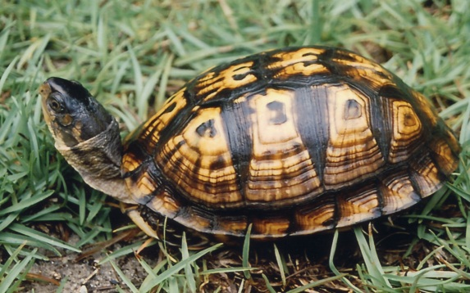
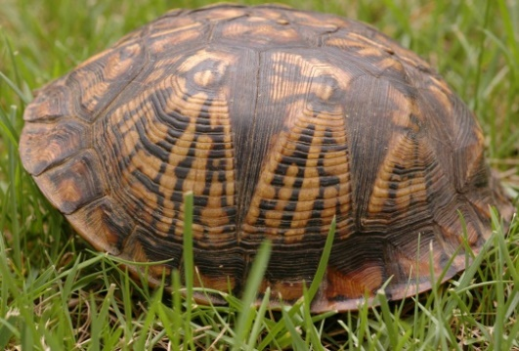
Figure 51. Box turtles normally have four lateral (pleural) scutes (left photo), but some turtles have more or less. The turtle in the photo on the right has three lateral scutes on the left side and five on the right (not shown). This should be noted in the Comments section of the data sheet.

Gil Grant
Dan Smith

